**CS 522 - FALL 2015**

**SMART - HEAD AND NECK THERAPY**

**WORKBOOK**

Team Members:

ANIRBAN ROY

ASHWIN VENKATARAMAN

CLIENTS: DAVID VOCK, CLIFTON. D. FULLER, GUADALUPE CANAHUATE

Table of Contents

1. Project Description 3
2. Requirements 3
3. Use Cases 4
4. Non Functional Requirements 12
5. Specifications 13
6. Goals 14
7. Group Prototypes 16
8. Alpha Release Report 20
9. Alpha Release Task Report 29
10. Beta Release 31
11. Beta Release Task Report 37
12. Beta vs Alpha release Analysis 40
13. Public Release 41

**Project Description:**

This project deals with a new methodology of precision medicine for head and neck cancers. With the number of cancers increasing every year, the aim of this project is the development of multiple outcome and adaptive treatment strategies for head and neck cancer. A part of this project is to prepare visualizations of the patient data. The client also expects to produce additional results through computational/statistical methods which need to be visualized in order to achieve the overall aim of this project.

The project essentially consists of two datasets – one being DICOM images of anonymized patients which visualize the head and neck area and the other being data in a tabular form which includes patient parameters like age, radiation therapy vs chemotherapy, total dosage, mortality rate etc. The aim for the class project is to integrate the two datasets, visualize them and note important patterns/trends.

**Requirements:**

The project’s functional requirements are as follows:

1. The system will have a web - based interface for the user to upload DICOM images.

2. The system will have a functionality to upload one DICOM image at once and also multiple DICOM images.

3. The web based interface should support viewing axial, coronal and sagittal views of the DICOM images loaded.

4. The system should support scrolling, zooming and panning of the DICOM images.

5. The data would be provided in a spreadsheet form, and based on the attributes, the system will have to produce certain visualizations. The exact details of the visualizations are not specified. It would be worked on the due course of the project.

6. The system should have function to choose different parameters to change/alter the visualization.

7. The system should also have a functionality to switch between the different views of the DICOM image.

8. The DICOM viewer should show details about the image (as contained in its header information).

9. The interface should support functionality to obtain patient details such as gender, age, tumor nodes, smoking status etc.

10. The interface should have a specific image of the lymphatic system of the head and neck, using which the user should be able to select the required lymph nodes/regions.

11. The system should be able to capture certain parameters from the doctor based on the patient information.

13. The system should have functionality for the user to interact with the DICOM images allowing the user to select/highlight the affected area.

14. Based on the parameters captured in requirement 11, the system should be able to locate the patient’s position on the visualization generated, based on the historical dataset.

15. The system should visualize the data broadly based on demographics, toxicity, treatment type and other factors (if taken into account).

16. The system would change the visualizations dynamically, based on the selection of the parameters by the user.

**SMART PROJECT – USE CASES**

**Use Case #1**

|  |  |
| --- | --- |
| **Use Case Name:** | Upload a DICOM image |
| **Actors Involved** | System User, Doctors |
| **Flow of Events** | 1. The user opens a web browser  2. The browser opens with a default home page/blank page.  3. The user opens the viewer of the DICOM viewer by typing the URL in a web browser.  4. The browser displays the DICOM image viewer.  5. The user clicks on the browse button to upload a specific image and clicks OK.  6. The DICOM viewer reads the file and displays the image |
| **Pre – Conditions** | The user has not uploaded an image already |
| **Post – Conditions** | The user can view the DICOM image on the browser. |
| **Quality Requirements** | 1. The loading of the DICOM image does not take more than 35 seconds. |

**Use Case #2**

|  |  |
| --- | --- |
| **Use Case Name:** | Upload multiple DICOM images |
| **Actors Involved** | System User, Doctors |
| **Flow of Events** | 1. The user navigates to the DICOM viewer by entering the URL.  2. The web browser displays the DICOM viewer.  3. The user selects selects the multiple images to be uploaded.  4. The viewer reads the images and loads the images |
| **Pre – Conditions** | The user has not uploaded an image already |
| **Post – Conditions** | The user can view the DICOM image on the browser. |
| **Quality Requirements** | 1. The loading of the set of DICOM images does not take more than 1 minute. |

**Use Case #3**

|  |  |
| --- | --- |
| **Use Case Name:** | Reconstruct DICOM image for different views |
| **Actors Involved** | System User, Doctors |
| **Flow of Events** | 1. The user opens a web browser  2. The browser opens with a default home page/blank page.  3. The user opens the viewer of the DICOM viewer by typing the URL in a web browser.  4. The browser displays the DICOM image viewer.  5. The user uploads a folder of DICOM images and selects OK.  6. The viewer parses the images and displays them on the browser.  7. The user selects the option to switch planes to display sagittal or coronal views.  8. The DICOM images displays the selected view. |
| **Pre – Conditions** | The user has not switched views after loading DICOM images |
| **Post – Conditions** | The user can view the DICOM image on the browser and switch views. |
| **Quality Requirements** | 1. The loading of the DICOM image does not take more than 35 seconds. |

**Use Case #4**

|  |  |
| --- | --- |
| **Use Case Name:** | Reconstruct DICOM image for different views |
| **Actors Involved** | System User, Doctors |
| **Flow of Events** | 9. The user opens a web browser  10. The browser opens with a default home page/blank page.  11. The user opens the viewer of the DICOM viewer by typing the URL in a web browser.  12. The browser displays the DICOM image viewer.  13. The user uploads a folder of DICOM images and selects OK.  14. The viewer parses the images and displays them on the browser.  15. The user selects the option to switch planes to display sagittal or coronal views.  16. The DICOM images displays the selected view. |
| **Pre – Conditions** | The user has not switched views after loading DICOM images |
| **Post – Conditions** | The user can view the DICOM image on the browser and switch views. |
| **Quality Requirements** | 2. The loading of the DICOM image does not take more than 35 seconds. |

**Use Case #5**

|  |  |
| --- | --- |
| **Use Case Name:** | Select affected areas |
| **Actors Involved** | System User, Doctors |
| **Flow of Events** | 1. The user opens the web browser and navigates to the URL of the system  2. The user uploads the DICOM image of the patient.  3. The system shows a picture of the lymphatic system of the head and neck.  4. The user selects the affected nodes.  5. The system responds by highlighting the affected areas in a specific colour/gradient. |
| **Pre – Conditions** | The user has uploaded DICOM images of the patient. |
| **Post – Conditions** | The user can view the DICOM image on the browser and switch views. |
| **Quality Requirements** | 3. The loading of the DICOM image does not take more than 35 seconds. |

**Use Case #6**

|  |  |
| --- | --- |
| **Use Case Name:** | Highlight area of interest in the DICOM image |
| **Actors Involved** | System User, Doctors |
| **Flow of Events** | 1. The user opens a browser and enter the URL to the system.  2. The user uploads the DICOM image for the patient  3. The system displays the DICOM image on the browser.  4. The user drags and selects an area of interest.  5. The system highlights the area in a different colour or applies a gradient to show the selected area.  6. The system brings up a small tooltip where in the user can enter the marking detail.   1. The user enters the detail of the selected area. 2. The system saves all the changes. |
| **Pre – Conditions** | The user has uploaded a DICOM image |
| **Post – Conditions** | The DICOM image is highlighted with the area of interest. |
| **Quality Requirements** | The time taken to reload the visualization does not take more than 10 seconds. |

**Use Case #7**

|  |  |
| --- | --- |
| **Use Case Name:** | Calculating inter-structure distance |
| **Actors Involved** | System User, Doctors |
| **Flow of Events** | 1. The user opens a browser and enter the URL to the system.  2. The user uploads the DICOM image for the patient  3. The system displays the DICOM image on the browser.  4. The user selects the two structures of interest using the mouse.  5. The user then selects the option to calculate inter-structure distance.  6. The system returns and displays the value of the inter-structure distance relative to the image. |
| **Pre – Conditions** | The user has uploaded a DICOM image |
| **Post – Conditions** | The DICOM image is highlighted with the area of interest. |
| **Quality Requirements** | The time taken to reload the visualization does not take more than 10 seconds. |

**Use Case #8**

|  |  |
| --- | --- |
| **Use Case Name:** | Enter Patient Sensitive Data |
| **Actors Involved** | System User, Doctors |
| **Flow of Events** | 1. The user opens the tab for entering the patient information.  2. The doctor enters patient information represented by each column  3. The user enters all the information and proceeds to the next tab. |
| **Pre – Conditions** | The user has already finished uploading the DICOM images. |
| **Post – Conditions** | The user has finished entering patient information and proceed to the visualization. |
| **Quality Requirements** | The time taken to load the page does not exceed 5 seconds. |

**Use Case #9**

|  |  |
| --- | --- |
| **Use Case Name:** | Variables for visualization |
| **Actors Involved** | System User, Doctors |
| **Flow of Events** | 1. The user opens a browser and enter the URL to the system.  2. The user uploads the DICOM image for the patient  3. The user enters the patient data in the respective fields.  4. The user submits the data for visualization.  5. The system responds to the uploaded data and displays the visualization  6. The user chooses/alternates between the variables by selecting/deselecting them on the visualization  7. The system updates the visualization based on the user response. |
| **Pre – Conditions** | The user has a visualization already displayed |
| **Post – Conditions** | The visualization updates itself based on the choice of variable selected. |
| **Quality Requirements** | The time taken to reload the visualization does not take more than 10 seconds. |

**Non - functional Requirements:**

1. **Availability Requirement:**

The system shall be available 24x7.

1. **Backup and Recovery Requirement:**

The system will have a backup taken on a daily basis.

1. **Performance Requirements:** 
   1. The DICOM image upload time would not take more than 1 minute
   2. Reconstruction of DICOM images will not take more than two minutes.
   3. User interaction with a DICOM image will have a latency of no more than 10 seconds.
   4. Queries shall return results within fifteen seconds.
   5. Updates shall take place within five seconds.

**4. Error – Handling Requirement:**

The system should handle expected and non-expected errors in ways that prevent loss of information and long downtime periods.

**5. Product Requirement:**

The interface of the system should be implemented using HTML/CSS, jQuery and JavaScript.

**6. Security Requirements:**

1. The system will have a user control based access.
2. Only the administrator or physician under charge can modify sensitive patient data.
3. All data and the system policies will comply to HIPAA regulations.

**Specifications**

Functional Specifications

Author: Ashwin Venkataraman

Last Updated: 12th October, 2015

**Disclaimer: This spec is not, by any stretch of the creative ability, complete.** The majority of the wording will need to be changed a few times before it is finished. The illustrations and design of the screens is demonstrated here just to show the fundamental usefulness. The real look and feel will be produced over the long run with the info of representation fashioners and iterative client input.

**Scenarios**

In designing products, it helps to imagine a few real life stories of how actual (stereotypical) people would use them. We'll look at two scenarios.

Scenario 1: Guadalupe

Guadalupe is a busy physician who attends to the emergency ward at ABC hospital in Model Town. In her usual workday, she receives a patient diagnosed with laryngeal cancer. She has to get done with the current patient and report the prognosis to the oncologist. She swiftly pulls up the system. She enters the patient details including age, gender, smoking status, number of tumor nodes and previous history of cancer. Guadalupe then uploads the patient’s scan images (processed in the DICOM format) into the interface. The interface produces a cool grayscale image with different views. Without wasting a second, she is able to spot the tumor and she selects and highlights the region. For the prognosis, she calculates the distance between the tumor located on the throat to the nasal cavity and soft tissues. Thanks to the built in function of the interface to calculate inter-structure distance, Guadalupe selects the different points and makes notes on interface and later submits the patient file.

Scenario 2: Elton

Elton is an oncologist at the ABC hospital in Model Town, who reviews patient scans and initial diagnosis from Guadalupe who works for him. Elton receives the initial prognosis report from Guadalupe. He is interested to find the patient health status with respect to the other patients in the past history.

Elton runs for lunch after which he returns to see all the DICOM images processed and ready for his review. Elton reviews Guadalupe’s marking of the affected areas and submits the patient detail for visualization. Based on the past history of patients, Elton is able to observe that the current patient can have an overall survival period of 36 months based on the dosage of chemotherapy, considering that the patient is a hispanic and is a chain smoker. Elton chooses different variables to see the patient’s position and understands that the patient needs immediate care due to his chronic smoking habits. Elton also sees that past patients with such diagnosis were not able to survive more than 24 months. Thanks to the patient’s healthy lifestyle other than smoking, Elton thinks this patient can survive longer. He saves the analysis record for his references and leaves to process the next patient.

**Goals**

1. **Low Ball Deliverable**

The low target defines the minimum functionality which will be incorporated in developing the system. The low target for this project would be:

* To design an interface for viewing DICOM images and the functionality of multi-planar reconstruction for sagittal and coronal views.
* To build a simple interface for entering patient detail and integrating the interface with the DICOM viewer.
* To produce very simple visualizations which may or may not show the user interesting patterns based on past patient history.

In achieving these goals, use cases #1, #2, #3, #4, #8 will be used. These use cases will be used in detail and the functionality will be implemented to the full extent.

**2. Mid Tier Deliverable**

The desirable target defines is the appropriate achievable target if there are no setbacks or major shortcoming in the project. For our project, the desirable target would be:

* To enable the user to upload multiple DICOM images and visualize the images.
* To produce visualizations which would identify interesting features based on user demographics, toxicity levels and treatment types.
* To add interaction to visualization by providing the user a list of variables which can be used to filter the results.

In order to achieve the mid tier deliverable, the use cases from the low tier deliverables will be implemented. In addition to that, use cases #5, #6, #7 and a part of #9 would be implemented.

**3. Full Bells and Whistles Deliverable**

The high target defines a set of goals which will be achieved if the planned schedule goes in accordingly and further additions can be made to improve the interface of the product, not affecting the functionality of the system. The high target for the project are stated down.

* To implement all goals of the mid - tier deliverable
* To implement fully functional DICOM viewer with functionality to move, drag and change DICOM slices.
* To view both sagittal and coronal views.
* To produce interesting patterns through visualizations and enabling user to add/remove layers.
* To predict an appropriate position of a new patient with respect to the historical data.

In achieving this goal, we would enhance use cases #6, #7 and #9. By using the word enhancing, we mean that we would increase the amount of interaction in the visualizations and DICOM viewers.

**Non Goals**

The application will not support the following features at this point of time:

* The system will not have the functionality to compute the inter-structural distance at a fully functional level.
* The visualization would be displayed on screen and would not have any function to save them as interaction becomes static.

**Group Prototypes**

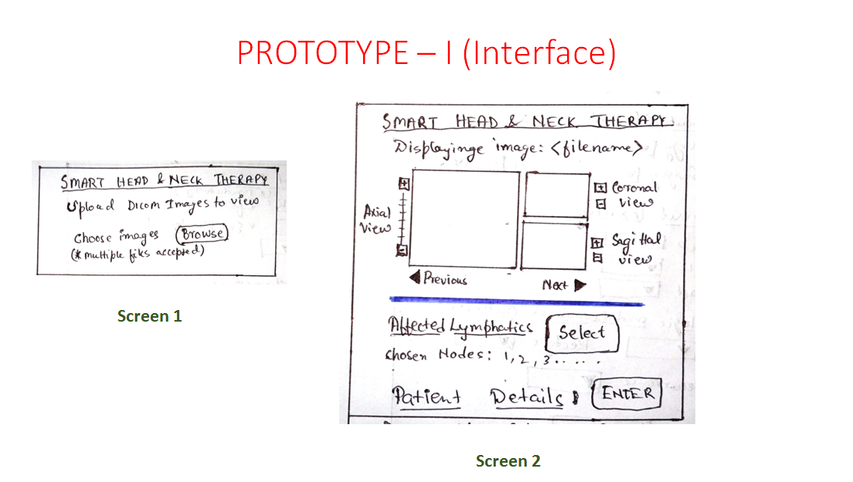

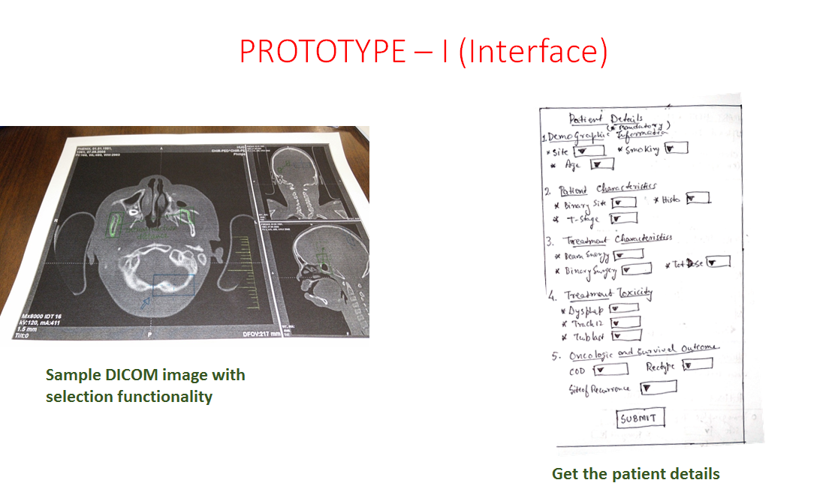

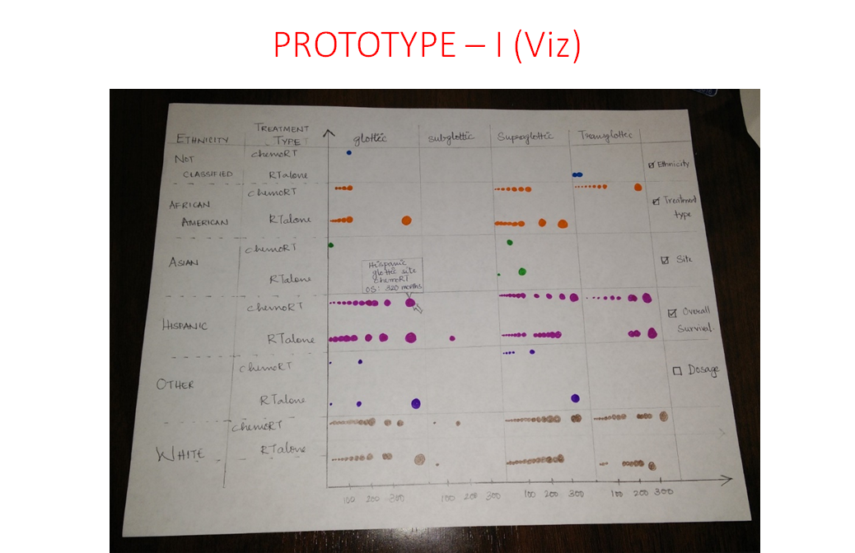

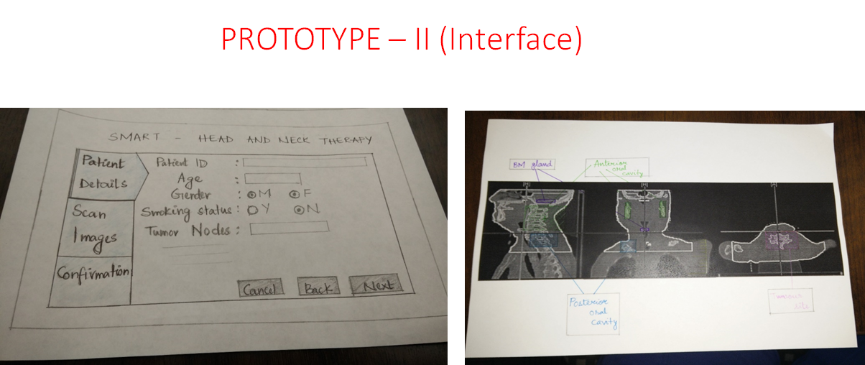

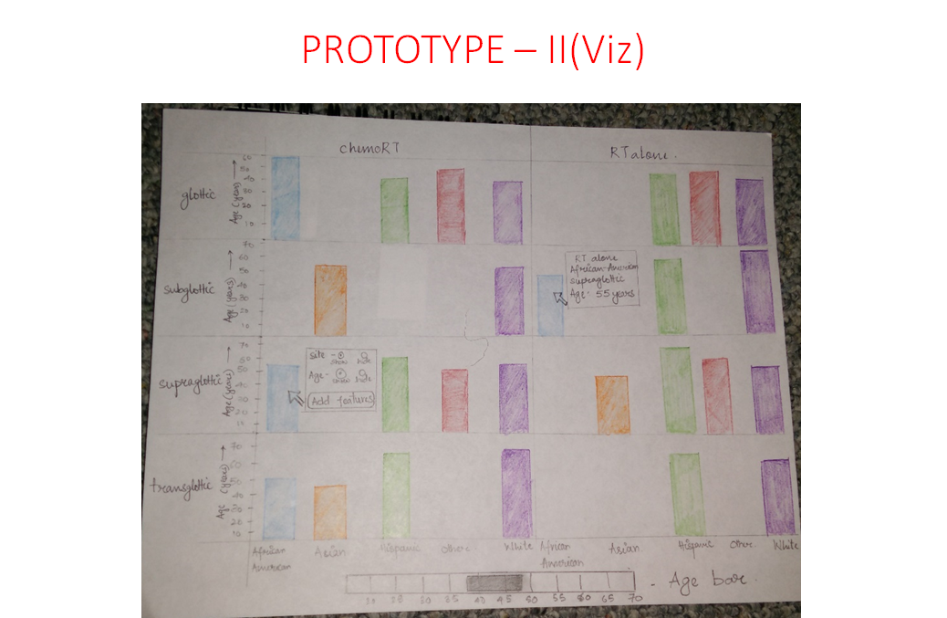

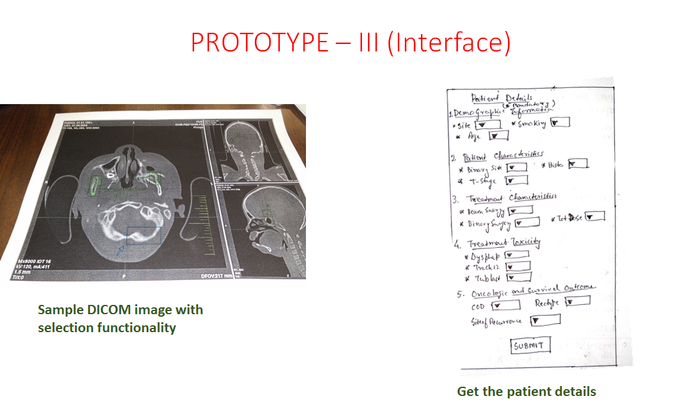

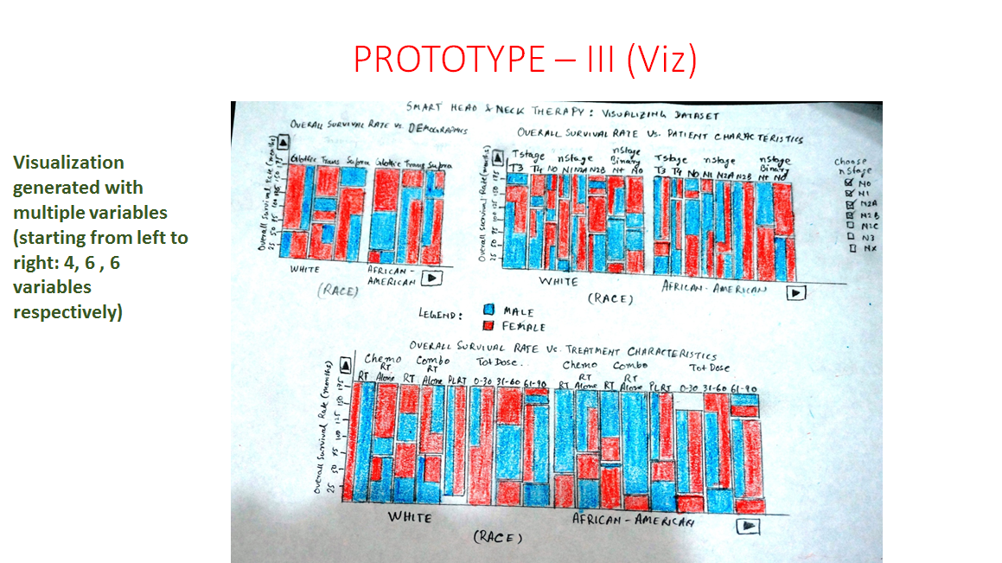

**Client Feedback**

The client is satisfied with all the prototypes. However, among the three prototypes demonstrated to the client, a combination of the best features of the three prototypes were approved. The following is the approved design:

1. The data entry part of prototype 2 is to be used for the final design
2. DICOM image with selection functionality should be like prototype 1.
3. The visualization to be created will include the Mosaic Plot of Prototype 3 and a line chart displaying the survival probability to the user.

**Collaborative Tools**

* **Repository: Github**

[**Head & Neck Therapy Repository**](https://github.com/anirban-roy/CS522_HCI)

* **Google Drive**
* **Google Docs**
* **Email**

**Alpha Release Report:**

The alpha release involved the first release of the software product with backend integration with the user interface. The following layers were accomplished:

1. **DICOM Viewer layer**

A user can successfully upload a DICOM image or a folder of DICOM images and observe the sliced images. The user is able to observe the sagittal and coronal views of the DICOM images along with the axial view. In case multiple images are uploaded, user can cycle the images using the arrow keys.

1. **Image layer to select affected lymph nodes**

The image of the human lymphatic system is placed alongside the DICOM viewer, so as to reduce cognitive load. The image provides a view of the human lymphatic system. Based on the observations made in the DICOM image, the user can select the affected nodes in the image. The selected nodes are highlighted in this image.

1. **Patient detail layer**

The user can enter the details of the patient such as patient ID, Name, Age, smoking status, stage of cancer, site of cancer, ethnicity etc. This section is designated to know the patient demographics.

1. **Visualization layer**

The visualization layer now has 5 kinds of visualizations - a bar chart showing an overview of the population of the study, a parallel coordinate chart to represent the various characteristics of the patient study, a treemap to represent the distribution of the population and the their survival probabilities, a line chart to represent the survival rates of the patient. Two kinds of treemaps are provided: treemap with area depending on the size of the population and another with the average survival probabilities of the population being explored.

The treemap and the line charts have drill down events to further show detail of the patient study.

**Screenshots**

1. **Home page**

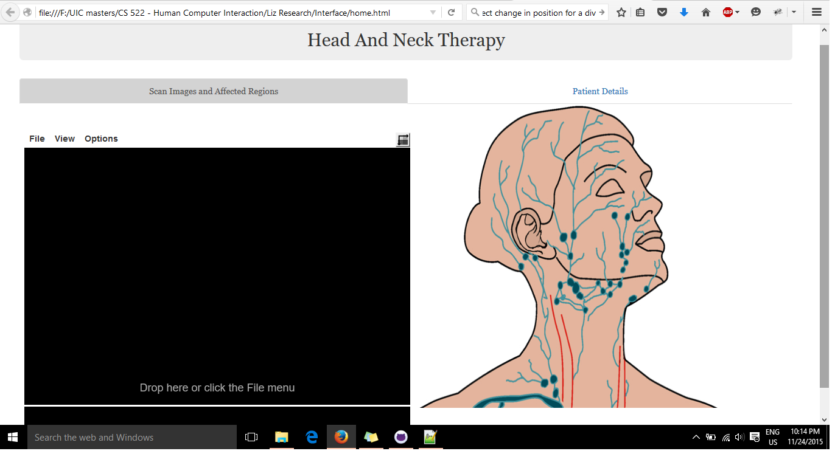

**2. View of patient Detail form**

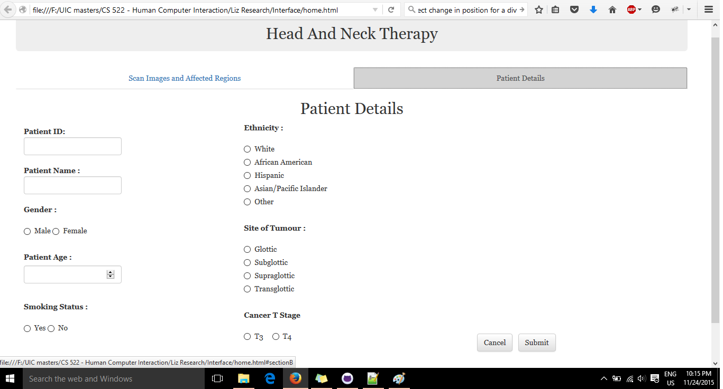

**3. Visualization Overview**

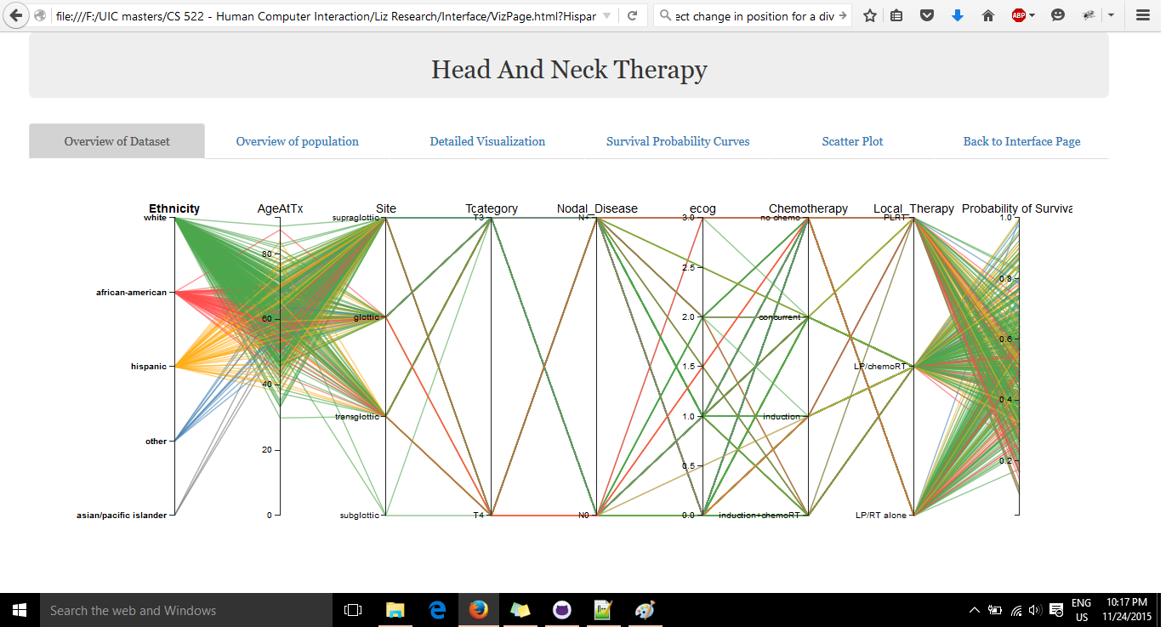

**4. Patient Population overview**

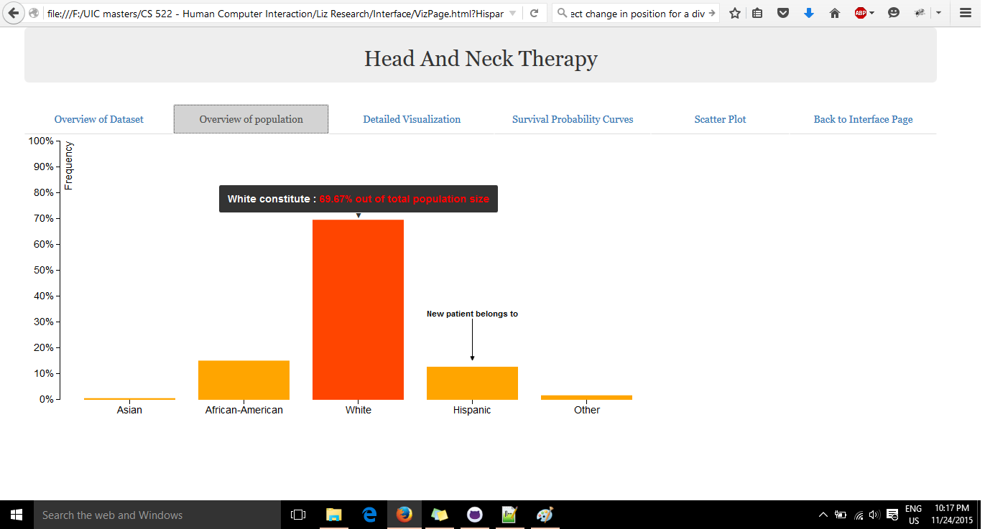

**5. Patient classification overview:**

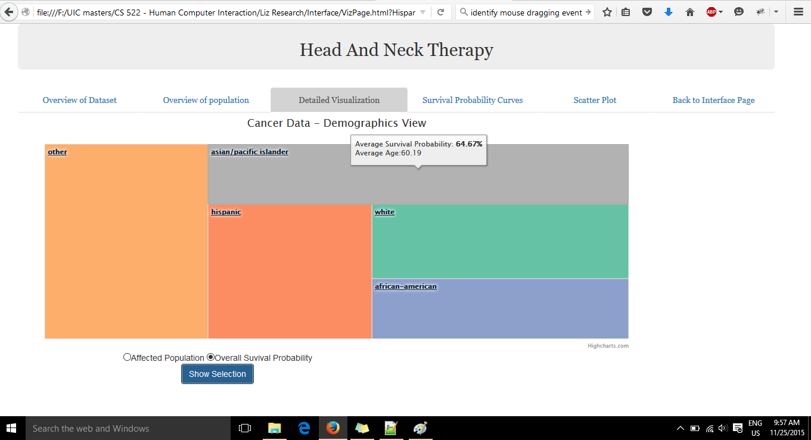

**Drill-down based on overall survival probability**

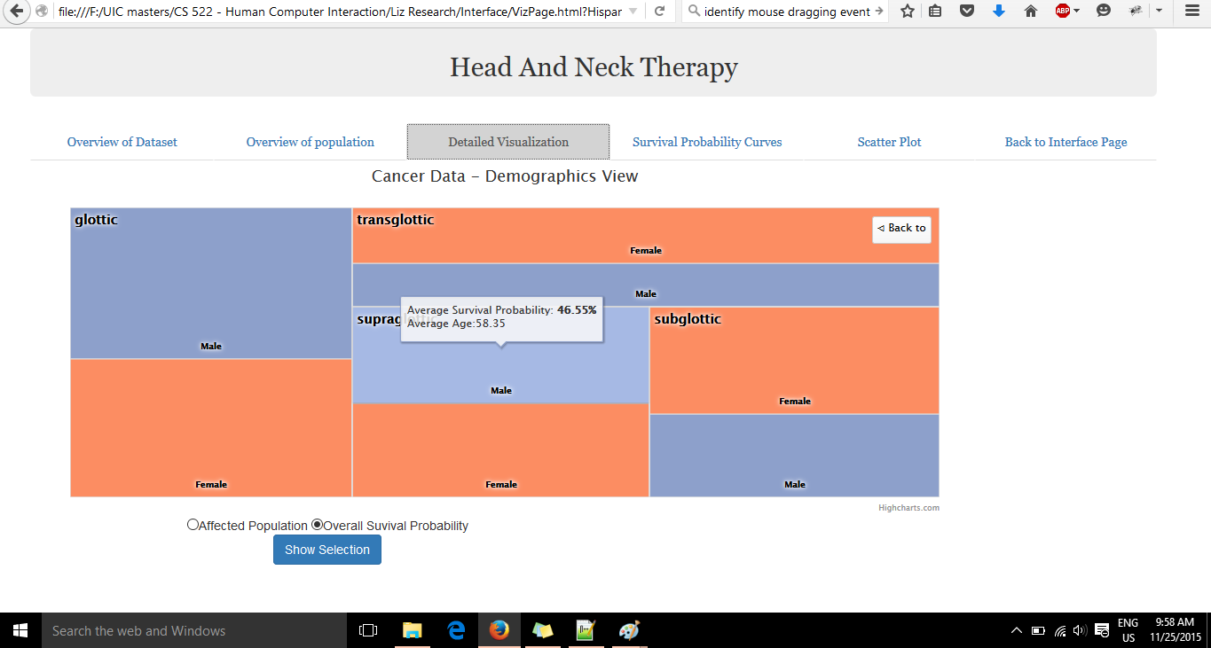

**6. Survival Probability curve for Hispanics based on different therapy**

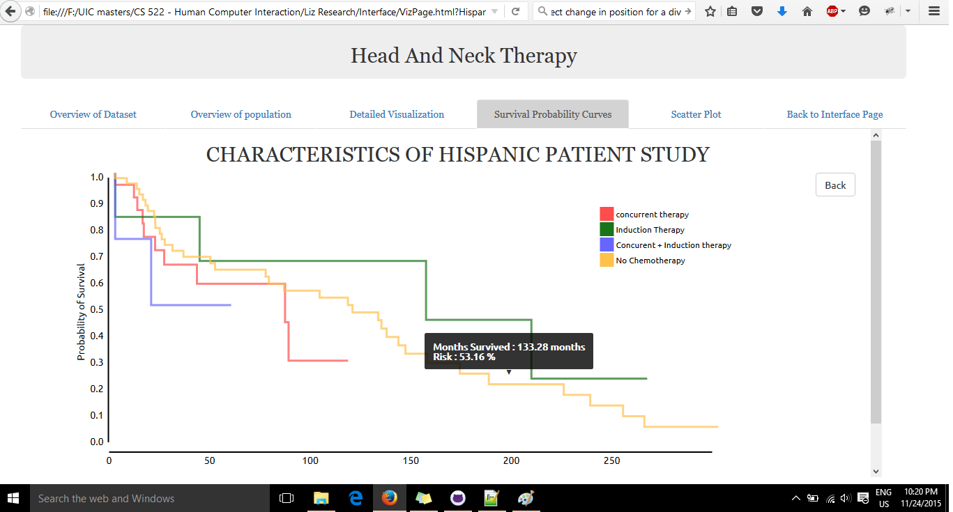

**7. Scatter plot**

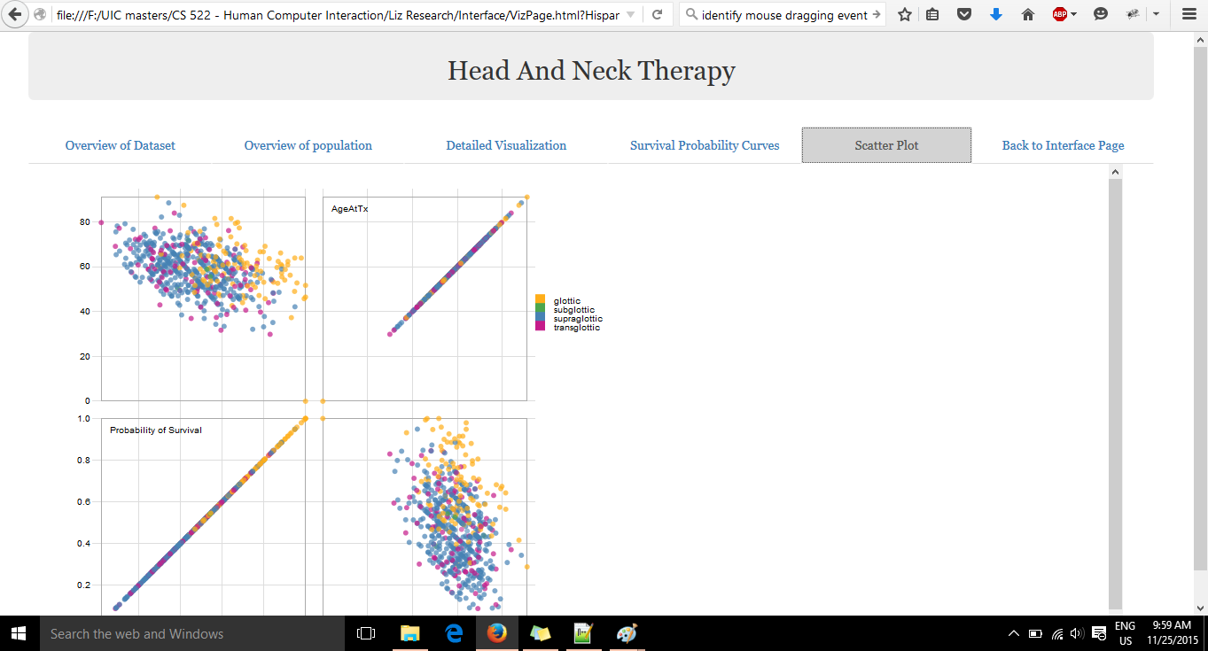

**What was done?**

With the current version of the application, we had to come up with several modifications from our prototypes. We changed the prototype design and made a simple design to have only two pages and not force the user to follow a series of operations to accomplish his task. Also, we were able to juxtapose the DICOM viewer and the image of the lymphatic system, so that the user is not forced to remember the affected nodes/areas. The user is able to enter the patient details and move over to the visualization page. The user is able to see the various representations of the population through the graphs.

Each graph gives the user a different perception. The bar chart represents the percentage of people classified according to ethnicity and the specific group in which the current patient belongs to. The parallel coordinate chart includes interaction, which helps a user to see common features such as tumour site, probability of survival. The treemap represents the classification of the population based on different variables. The probability curves show the various rates of survival, along with the specific set of therapy undergone by patients.

**What was intended?**

Our intention was to create a juxtaposed view of at least two charts which would help the user compare the different perceptions and understand the current patient study. The juxtaposition would enable interaction between the user and the two charts simultaneously, thereby showing a set of patients within a specific range of variables. Also, another intention was to let the user discover interesting patterns by placing the new patient along with the graph.

The new patient would be accommodated within each graph so as to understand which survival therapy would be most suited for the patient. The interaction with the DICOM viewer was to be incorporated with the interface which we were unable to do.

**What we learnt?**

* Creating multiple d3 charts within the same webpage needs to be done with utmost care. The addition of multiple svg components messes up the maps and the associated elements such as tooltips also get messed.
* Creating interaction between two maps by juxtaposing them needs a lot of effort as we need to track the specific graph, the area of the graph and its corresponding action. If the two graphs represents different sets of variables, finding correlation is a big challenge.
* Creating maps with categorical data and interaction is still a tough part. Most examples given by the professor on Piazza had time series data which cannot be completely applied to categorical data.
* Creating charts which physicians could understand, and also representing the entire data was another huge challenge. Making the charts complex did solve the problem of representing categorical data, but it violated the principle of making the interface user friendly and intuitive, especially to users unfamiliar with complex visualizations.

**Alpha Release Structured Interview:**

We used a structured interview to get the feedback from the tester based on his experience. The following questions were asked:

1. On a scale of 1 to 10, how would you rate the user interface it terms of design and feel, with 1 being poor and 10 being best?
2. Did you find the interface difficult to understand or navigate?
3. At any time, were you unable to proceed? If yes, describe.
4. Were you able to understand how to complete the tasks using the interface?
5. Did you feel the essential elements of the interface were covered?
6. How insightful was the visualization?
   1. Bar Chart
   2. Parallel Coordinate chart.
   3. TreeMap
   4. Line chart
   5. Scatter Plot Matrix
7. Was the interface aesthetically appealing?
8. One feature that you liked about the interface?
9. Are there any improvements that could be done to make application better?
10. Other feedback (if any).

The responses to these questions are as follows:

**Tester 1:**

1. On a scale of 1 to 10, how would you rate the user interface it terms of design and feel, with 1 being poor and 10 being best - **7**
2. Did you find the interface difficult to understand or navigate - **Easy to navigate, but understanding the task description was not easy to map to the system**
3. At any time, were you unable to proceed? If yes, describe. - **Cannot understand how to view charts from home page**
4. Were you able to understand how to complete the tasks using the interface - **Yes, maybe needed some hints**
5. Did you feel the essential elements of the interface were covered - **As per the task it felt complete**
6. How insightful was the visualization?
   1. Bar chart
   2. Parallel Coordinate chart - **Tough to understand**
   3. TreeMap and its drill down maps - **was specific and clear**
   4. Line chart - **very insightful**
   5. Scatter Plot Matrix - **did not completely represent the overall dataset maybe.**
7. Was the interface aesthetically appealing - **Yes**
8. One feature that you liked about the interface - **Tabbed view of visualizations was very good**
9. Are there any improvements that could be done to make application better - **Selection of DICOM images was not clear**
10. Other feedback (if any) - **Need of tutorial, hints to understand the charts**

**Tester 2:**

1. On a scale of 1 to 10, how would you rate the user interface it terms of design and feel, with 1 being poor and 10 being best - **7**
2. Did you find the interface difficult to understand or navigate - **Yes, difficult according to the task set**
3. At any time, were you unable to proceed? If yes, describe. - **Couldn’t proceed with the treemap, confused between a radio button and the letter ‘O’ in the label.**
4. Were you able to understand how to complete the tasks using the interface - **Yes.**
5. Did you feel the essential elements of the interface were covered - **Yes, all elements were intact but not intuitive i.e. no indication that patient details are to be filled first**
6. How insightful was the visualization?
   1. Bar chart - represents the overall population in a good manner
   2. Parallel Coordinate chart - **Tough to understand**
   3. TreeMap and its drill down maps - **very good and easy to understand**
   4. Line chart - **insightful and felt filters were intuitive**
   5. Scatter Plot Matrix - **did not completely represent the overall dataset maybe.**
7. Was the interface aesthetically appealing - **Yes**
8. One feature that you liked about the interface - **The level of detail and the filters for each chart were very good.**
9. Are there any improvements that could be done to make application better - **Differentiate between radio button and have adequate gap between text and radio button.**
10. Other feedback (if any) - **Make components obvious - i.e. tell the user that patient details have to be filled first.**

**Tester 3:**

1. On a scale of 1 to 10, how would you rate the user interface it terms of design and feel, with 1 being poor and 10 being best - **7**
2. Did you find the interface difficult to understand or navigate - **Yes, difficult according to the task set**
3. At any time, were you unable to proceed? If yes, describe. - **Unable to proceed with the interaction of the parallel coordinate chart**
4. Were you able to understand how to complete the tasks using the interface - **Yes.**
5. Did you feel the essential elements of the interface were covered - **All elements were covered, however there was no back button for error recovery.**
6. How insightful was the visualization?
   1. Bar chart - very simple visualization
   2. Parallel Coordinate chart - **Tough to understand**
   3. TreeMap and its drill down maps - **Good and intuitive**
   4. Line chart - **Good**
   5. Scatter Plot Matrix - **Didn’t find it intuitive**
7. Was the interface aesthetically appealing - **Yes**
8. One feature that you liked about the interface - **Simple interface and no saturated colours**
9. Are there any improvements that could be done to make application better - **Change text colours of tabs names. They look like links and not tabs**
10. Other feedback (if any) - **Represent buttons in a better way. Have a back button for error recovery.**

**Alpha Release Task Report:**

Each tester was given a time span of 15 minutes and the following tasks:

* Upload a folder of DICOM of images and move slices of the image
* Interact with the parallel Coordinate chart by selecting the patients who have survival probability levels ranging from 0.5 - 0.8 with a supraglottic site of cancer.
* Display overall survival probability of white patients in the treep map, entitled in the section detailed visualization.
* Select an affected lymph node by name parietal node on the human lymphatic system.

There was a variation in the parameters for each tester, for example, instead of choosing the probability of white patients, one tester was asked to choose the same parameter for hispanics.

Each user was measured on the basis of the time taken to complete a task and the task completion factor. The following tables illustrate the results from the testers:

**User 1**

|  |  |  |  |
| --- | --- | --- | --- |
| Task | Time on Task | Task Success | Error(s) made |
| Upload DICOM images and move slices of the image | 1 min 22 sec | PASS | Uncertainty in uploading single image or multiple images |
| Interact with the parallel Coordinate chart by selecting the patients who have survival probability levels ranging from 0.5 - 0.8 with a supraglottic site of cancer. | 1 min 50 sec | PASS | Unable to notice how to interact with chart |
| Display data of Hispanics under the treemap section entitled detailed visualization | 1 min 10 sec | PASS | No error |

Observations:

1. The user had trouble navigating from the first page to the next section where he had to enter the details of the patient.
2. The user felt that the visualization page was easy to navigate and the visualizations showed a good representation.
3. The user had difficulty understanding if the folder was to be selected or multiple images be selected to upload to the DICOM viewer.
4. The user also felt the treemaps and the specific drill-down was insightful, specific and clear.

**User 2**

|  |  |  |  |
| --- | --- | --- | --- |
| Task | Time on Task | Task Success | Error(s) made |
| Select the parietal and buccal nodes in the human lymphatic system | 48 sec | PASS | No error |
| Display the probability curves of African American patients pertaining to different types of therapy | 2 min 12 sec | PASS | Unable to notice drill down event of line chart i.e. chart of pointer. Random clicking helped the user understand the drill down. |
| Display data of White patients under the treemap section entitled detailed visualization | 3 min 40 sec | PASS | No error |

Observations:

1. The user was stuck at a point where he was confused between a radio button and the letter ‘O’ in Overall’ under the TreeMap visualization.
2. The user felt the filters in the charts were good.
3. The user felt the navigation of the interface was tough according to the description of the task.
4. User was confused whether to enter patient details or system will display some patient details under the Patient details layer.

**User 3**

|  |  |  |  |
| --- | --- | --- | --- |
| Task | Time on Task | Task Success | Error(s) made |
| Upload DICOM images on the viewer and select the parietal node in the affected regions | 23s | PASS | No errors |
| Interact with the parallel Coordinate chart by selecting the patients who have survival probability levels ranging from 0.5 - 0.8 with a glottic site of cancer. | 3mins | Issue with navigation, but passed task | Unable to identify interaction with chart. Struggled to notice change in pointer for brush event. Passed task after trial and error |
| Display data of Asians patients under the treemap section entitled detailed visualization | 2 mins | PASS | Needed effort in navigating to treemap and identifying the drill down map. |

Observations:

1. The user had difficulty interacting with the parallel coordinate chart. He expressed the need for a tutorial to assist the user for interaction.
2. The user expressed a need to change the colours on the navigation bar as he felt they represented links rather than tabs.
3. The user felt there should be valid checks to ensure that the age parameter isn’t entered zero or any kind of negative parameter.

**Beta Release Report:**

The beta release encompassed the release of a new interface having the DICOM viewer, the image of the human lymphatic system and the patient details data entry sections sharing the same view port. Given below are the different changes in the layers:

1. **DICOM Viewer layer**

This functionality is preserved from the alpha release. An user may upload a single DICOM image of a directory of DICOM images and view them. System allows the user to cycle through the images using the arrow keys from keyboard. The sagittal, coronal and axial views of the DICOM images are displayed to the user in the interface.

1. **Image layer to select affected lymph nodes**

The image layer features an interactive image of the human lymphatic system. In the beta release the image has been changed such that the fill color of the image is lighter instead of beige. All the lymph nodes are labelled for the user to identify and locate the lymph node. The nodes are also bigger such the they can be easily selected by the user. This is done as per client request and allows the easy identification of the nodes.

1. **Patient detail layer**

The user can enter the details of the patient such as patient ID, Name, Age, stage of cancer, site of cancer, ethnicity and sex. This section is designated to know the patient demographics information. Once these are provided, the system proceeds to display the various visualizations.

1. **Visualization layer**

In the beta release the visualization layer is integrated with the information from the patient details section. The based on the information from the patient details, only the corresponding data points matching the patient demographic characteristics are displayed. All the visualizations are juxtaposed sidewise and displayed in same viewport. This allows the users to visualize the data easily, compare them and draw meaningful and useful inferences. The beta release features a treemap, line chart, scatter plot matrix and a parallel coordinate chart. The drill down events in the treemap is removed since here specific data for the particular demographics are displayed. Since understanding the parallel coordinates requires prior experience and is difficult, a tutorial has been provided for the user to find out how the chart encodes and displays the information.

**Screenshots**

1. **Home page**

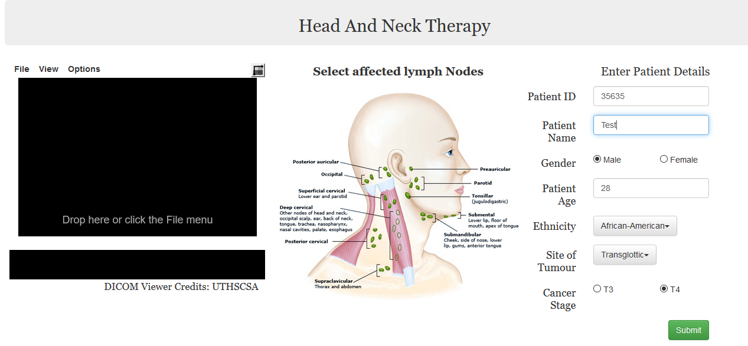

1. **Visualization**

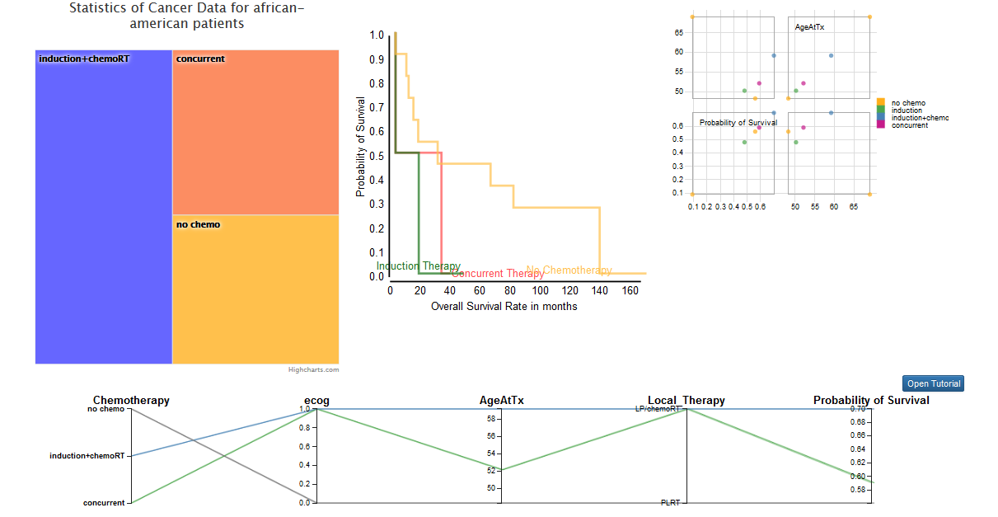

**What was done?**

The interface has been changed entirely after the alpha release. The three layers: DICOM Viewer, Lymphatic system and the patient details are placed in a same view port to decrease memorization . Furthermore, the lymphatic system image is changed such that all the lymph nodes has labels indicating the node. The size of the nodes are clustered allowing the users to select the affected nodes altogether. The collected demographics information in the patient information is used as a filter to display only the corresponding data points such the user has is not overwhelmed with information and form a easy comparison of similar data points/patients. The visualizations are juxtaposed sidewise in a common viewport allowing the user to compare all of them to explore patterns and deduce meaningful information. A tutorial has been provided for understanding the parallel coordinate chart since its relatively more complex to understand and explore. Apart from displaying filtered data, the system also enables the

**What was intended?**

The intention was to have the juxtaposed visualizations implemented with brushing and linking enabling users to highlight data points in one of the chart which would highlight the corresponding data points in the other linked charts. Both these features can be implemented but achieving them in the given timeline was a difficult task. As such, for beta release we were not able to implement these features. We set these features to be rolled out with the final demonstrations.

**What we learnt?**

* Creating juxtaposed view of different visualizations is a tedious task since proper scaling of the visualizations is very important so that the information does not become illegible.
* Creating multiple d3 charts within the same web page needs to be done with utmost care. The addition of multiple svg components messes up the maps and the associated elements such as tooltips also get messed.
* Creating interaction between two maps by juxtaposing them needs a lot of effort as we need to track the specific graph, the area of the graph and its corresponding action. If the two graphs represents different sets of variables, finding correlation is a big challenge.
* Creating visualizations which are dynamic and gets generated based on the user input to filter data is a challenging task and requires diligent efforts filtering the data from the dataset.
* Creating the interface such that it reduces memorization but still preserve legibility requires utmost care and brainstorming design techniques.

**Beta Release Structured Interview:**

We used a structured interview to get the feedback from the tester based on his experience. The following questions were asked:

We used a structured interview to get the feedback from the tester based on his experience. The following questions were asked:

1. On a scale of 1 to 10, how would you rate the user interface it terms of design and feel, with 1 being poor and 10 being best?
2. Did you find the interface difficult to understand or navigate?
3. At any time, were you unable to proceed? If yes, describe.
4. Were you able to understand how to complete the tasks using the interface?
5. Did you feel the essential elements of the interface were covered?
6. How insightful was the visualization?
   1. Parallel Coordinate chart
   2. TreeMap
   3. Line chart
   4. Scatter Plot Matrix
7. Was the interface aesthetically appealing?
8. One feature that you liked about the interface?
9. Are there any improvements that could be done to make application better?
10. Other feedback (if any).

The responses to these questions are as follows:

**Tester 1:**

1. On a scale of 1 to 10, how would you rate the user interface it terms of design and feel, with 1 being poor and 10 being best? -**10**
2. Did you find the interface difficult to understand or navigate? -**Nothing difficult, parallel coordinate chart was easy with tutorial**
3. At any time, were you unable to proceed? -**If yes, describe. No**
4. Were you able to understand how to complete the tasks using the interface? -**Yes**
5. Did you feel the essential elements of the interface were covered? -**Yes**
6. How insightful was the visualization?
   1. Parallel Coordinate chart **- very interesting and insightful**
   2. TreeMap - proper colours and names. -**Tooltip useful**
   3. Line chart **- Shows everything clearly**
   4. Scatter Plot Matrix
7. Was the interface aesthetically appealing? **-Yes**
8. One feature that you liked about the interface? -**No deviations or distractions caused to the user**
9. Are there any improvements that could be done to make application better?
10. Other feedback (if any). -**Treemap has a bit of text going away, change that.**

**Tester 2:**

1. On a scale of 1 to 10, how would you rate the user interface it terms of design and feel, with 1 being poor and 10 being best?- **9**
2. Did you find the interface difficult to understand or navigate? -**No, very simple**
3. At any time, were you unable to proceed? -**If yes, describe. No**
4. Were you able to understand how to complete the tasks using the interface? -**Yes**
5. Did you feel the essential elements of the interface were covered? **-Yes**
6. How insightful was the visualization?
   1. Parallel Coordinate chart **- Interesting but a bit tough to understand without tutorial**
   2. TreeMap **- Good to show overall population and its splitup**
   3. Line chart
   4. Scatter Plot Matrix
7. Was the interface aesthetically appealing? -**Yes, very simple colours and nothing saturated**
8. One feature that you liked about the interface? **- Selection of lymph nodes with appropriate feedback.**
9. Are there any improvements that could be done to make application better?
10. Other feedback (if any). **-Nothing specific.**

**Tester 3:**

1. On a scale of 1 to 10, how would you rate the user interface it terms of design and feel, with 1 being poor and 10 being best?-**9.5**
2. Did you find the interface difficult to understand or navigate?-**No. It was easy**
3. At any time, were you unable to proceed? If yes, describe. -**I was briefly stuck searching for a "Home" or a "back" button to go back to the homepage. I wouldn't call it completely stuck, since I was able to go to the home page by changing the URL**
4. Were you able to understand how to complete the tasks using the interface?**-Yes**
5. Did you feel the essential elements of the interface were covered?**-Except the "home/back" button, I feel everything else was well designed**
6. How insightful was the visualization?
   1. Parallel Coordinate chart
   2. TreeMap
   3. Line chart
   4. Scatter Plot Matrix

**All the visualizations were good.**

1. Was the interface aesthetically appealing? **-Yeah, definitely**
2. One feature that you liked about the interface? **- Very clean design**
3. Are there any improvements that could be done to make application better? **-If the legends are bigger, it would be nice :) Maybe place them in a centralized location? I understand that it would not be an easy task to code it. But it would be a nice change to have.**
4. Other feedback (if any). **-Excellent work ! Good job**

**Beta Release Task Report:**

Each tester was given a time span of 15 minutes and the following tasks:

* Select an affected lymph node.
* Display the visualizations of all similar patients for a given patient with certain demographics.
* Display the visualizations for a certain demographics information but for all the ethnicities.

The given tasks were given to tester with variations in the type of information they need to provide as input and infer from the visualizations.

Each user was measured on the basis of the time taken to complete a task and the task completion factor. The following tables illustrate the results from the testers:

**User 1**

|  |  |  |  |
| --- | --- | --- | --- |
| Task | Time on Task | Task Success | Error(s) made |
| Select parotid affected lymph node. | 11 sec | PASS | No errors were made |
| Display the visualizations of all similar patients for a given male patient, 54 years old, African-American ethnicity, cancer in T3 stage and at the supraglottic site. | 1 min 10 sec | PASS | No error |
| Display the visualizations for all the ethnicities with following demographics: T3 stage cancer,glottic stage of cancer and male. | 1 min 50 sec | PASS | No error |

Observations:

1. Able to understand the graphs completely.
2. Able to interact with parallel coordinate chart after seeing the tutorial
3. Unable to relate between scatter plot and line chart. Linking and brushing
4. Did not get stuck anywhere

**User 2**

|  |  |  |  |
| --- | --- | --- | --- |
| Task | Time on Task | Task Success | Error(s) made |
| Select deep cervical affected lymph node. | 10 sec | PASS | No errors were made |
| Display the visualizations of all similar patients for a given male patient, 54 years old, African-American ethnicity, cancer in T3 stage and at the supraglottic site. | 2 mins | PASS | No error |
| Display the visualizations for all the ethnicities with following demographics: T3 stage cancer, glottic site of cancer and male. | 1 min 35 sec | PASS | No error |

Observations:

1. Had initial difficulty understanding to enter details in the form
2. No difficult navigating the interface
3. Understood parallel coordinate chart even without domain knowledge.
4. Tester would like to see graph sizes in proportion - the current view has a view where the size reduces.

**User 3**

|  |  |  |  |
| --- | --- | --- | --- |
| Task | Time on Task | Task Success | Error(s) made |
| Select super cervical affected lymph node. | 27 sec | PASS | No errors were made |
| Display the visualizations of all similar patients for a given male patient, 54 years old, African-American ethnicity, cancer in T3 stage and at the supraglottic site. | 1 mins 20 sec | PASS | No error |
| Display the visualizations for all the ethnicities with following demographics: T3 stage cancer, glottic site of cancer and male. | 1 min 50 sec | PASS | No error |

Observations:

1. Understood the interface well
2. Unable to find legend even though line charts had the labels written right next to them
3. Not able to completely understand the relationship between the treemap and the probability curve chart
4. No difficulty navigating the interface.

**Beta vs Alpha Release:**

The major changes in beta release after the alpha release is the change in the interface with juxtaposition of the layers and the multiple visualizations. Another marked change is the lymphatic system image with the nodes labelled. There is a dramatic improvement in the task timing. The timing comparison of both releases are given below:

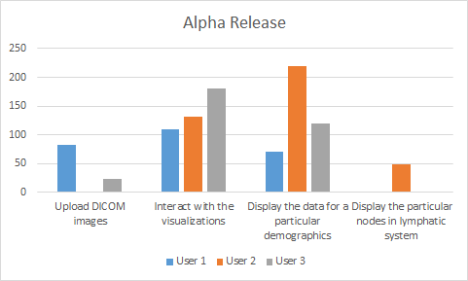

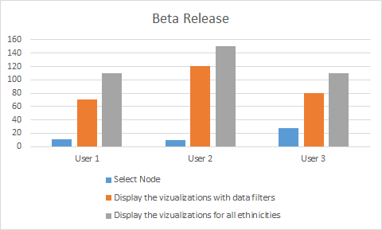

We were also able to observe learnability with the current version of the interface. Based on the tester’s feedback, these were the following observations:

* Based on the change in interface, the users were able to navigate the interface in a much easier manner and understand the visualizations as well.
* The users were able to understand the tutorial and make a comparison and relate to the plots in a way that put lesser cognitive load in the user.
* Having the visualizations on the same page makes comparison easier for the user.
* The presence of a tutorial to operate a parallel coordinate chart made it easier for the tester to interact with the chart.

**Public Release**

Sum up

* what are you most proud about your project
  + Implementing everything from scratch
  + Changing our prototypes and developing them quickly everytime without any delay
  + Integrating 4 kinds of visualizations in one single page with appropriate interaction.
  + Coming up with different visualizations which would integrate both categorial and numeric data.

What you learned from the client testing

* Client wants a specific risk factor and a specific value of the probability survival to be listed on the interface
* Client wants to automate partially the process of selecting the affected lymph nodes.

Client feedback

* The client is satisfied with the display and likes the interactions between the charts.
* The client would like to see a back button rather than using just a browser button.

What you would do differently next time.

* We would like to understand how to integrate and categorical data simultaneously.
* Understand the need for correlation and the kind of correlation the client is looking out for.
* Explore more about brushing and linking multiple svg components.

Live link

<http://avenka24.people.uic.edu/home.html>

Client feedback

Our client had a positive feedback with a few minor changes in the interface. He wanted to see a specific value of confidence with a risk factor for the overall probability survival function.

Also, he preferred the automation of selection of affected lymph nodes, which was out of the scope of this project for the class.

Report

The application was designed mainly to integrate spatial and non spatial data, thereby to create a novel interface which would assist the user in visualizing the spatial and non spatial datasets.

With our primary prototype, we understood that it did not have a linked view display and therefore, we had to scrap the prototype after the Wizard of Oz demo. Also, the client preferred an interface which had lesser amount of clicks and less amount of windows being clicked/visited.

From the wizard of Oz demo to the alpha release, we faced the challenge of designing new prototypes and simultaneously focussing on integrating the back end data with the interface. With the alpha release, we were able to successfully produce visualizations, but the visualizations stood as stand alone graphs without any interaction between them. Adding interactions to each chart was an easy task, but to integrate all charts in a single view and apply filters was the next challenge we faced.

From the time of the alpha release to the beta release, we understood the challenge faced and applied the concepts learned in class. We came up with a juxtaposed view for the interface and the visualizations and reduced the number of clicks and overall navigation.

The main challenge was to integrate all charts under a single page with multiple svg components. We were able to design the interface carefully to overcome the challenges of having multiple svg components on the same web page. We were able to achieve a good interaction by using brushing and linking in the visualizations. We aim to add more interactions if there was more time.

Instructions to run/use the code:

1. The code is in the repository under the link: <https://github.com/anirban-roy/CS522_HCI>.
2. The project can be cloned/downloaded as a zip file and can be run.
3. To run the project, you would require XAMPP server.
4. XAMPP can be downloaded at<https://www.apachefriends.org/index.html>
5. Extract the project from the downloaded zip file and place it in a folder.
6. If you have XAMPP server, navigate to the htdocs folder of XAMPP and create a new folder named - “project” and paste all the project files in that folder.
7. Run XAMPP control panel and ensure that the Apache Web Server is running. Once the webserver is running, open a browser and navigate to <http://localhost/project/home.html>
8. The homepage of the interface would be displayed and one can use it thereafter.